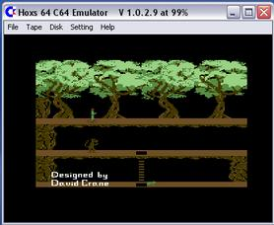
Hoxs64 is a Commodore 64 emulator for Windows. The emulator is still under development so some features may be missing.

